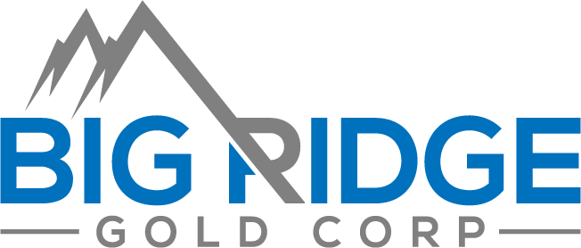

NEWS RELEASE
BIG RIDGE COMPLETES SALE OF ONTARIO PROPERTIES
Toronto, Ontario, March 1, 2022: Big Ridge Gold Corp. (TSX-V: BRAU) (OTCQB: ALVLF) (“Big Ridge”) announces the closing of the sale of its 100% owned Ontario mining properties to Caprock Mining Corp. (“Caprock”) pursuant to a sale agreement dated March 11, 2021. As consideration, Caprock issued a total of 10,000,000 common shares (the “Caprock Shares”) to Big Ridge from treasury at a deemed price of $0.10 per Caprock Share for aggregate deemed consideration of $1,000,000.
Immediately prior to closing of this transaction, Big Ridge did not own or control any Caprock Shares. Following closing, Big Ridge owns 10,000,000 Caprock Shares, representing approximately 24.77% of the issued and outstanding share capital of Caprock. These Caprock Shares were issued under a prospectus exemption and are also subject to an escrow agreement providing for a three-year escrow, and become free-trading according to the following schedule:
Date | Number of shares
June 29, 2022* | 1,000,000
July 26, 2022 | 1,500,000
January 26, 2023 | 1,500,000
July 26, 2023 | 1,500,000
January 26, 2024 | 1,500,000
July 26, 2024 | 1,500,000
January 26, 2025 | 1,500,000
*Released from escrow upon issuance, but subject to a hold period of four months and one day under applicable securities laws.
Big Ridge will continue to monitor the business, prospects, financial condition and potential capital requirements of Caprock. Depending on its evaluation of these and other factors Big Ridge may from time to time in the future increase or decrease its direct or indirect ownership, control or direction over the Common Shares or other securities of Caprock through market transactions, private agreements, subscriptions from treasury or otherwise, and may from time to time engage in discussions with, or make proposals to, Caprock or other third parties regarding any of the matters listed in paragraphs (a) through (k) of Item 5 of Form NI 62-103F1 - Required Disclosure under the Early Warning Requirements of the Canadian Securities Administrators.
About Big Ridge Gold Corp.
Big Ridge Gold Corp. is an exploration and development company managed by a disciplined and experienced team of officers and directors. The Company is committed to the development of advanced stage mining projects using industry best practices combined with strong social license from our local communities. Big Ridge owns a 100% interest in the highly prospective Oxford Gold Project located in Manitoba and the Destiny Gold Project in Quebec. Big Ridge is the operator of the Hope Brook Gold Project located in Newfoundland and Labrador.

For more details regarding the Company’s projects, please visit our website at www.bigridgegold.com

ON BEHALF OF THE BOARD,

Mike Bandrowski,
President & CEO
For further information, including a copy of the corresponding report filed with Canadian securities regulators, please visit www.sedar.com or contact:
Mike Bandrowski,
President & CEO
BIG RIDGE GOLD CORP.
18 King St. East, Suite 1400
Toronto, ON, M5C 1C4
Tel: 416-540-5480
Email: Mike@bigridgegold.com

Neither the TSX Venture Exchange nor its Regulation Services Provider (as that term is defined in the policies of the TSX Venture Exchange) accepts responsibility for the adequacy or accuracy of this release.

Cautionary Note Regarding Forward-Looking Statements

This news release includes certain "forward-looking information” and "forward-looking statements” (collectively "forward-looking statements”) within the meaning of applicable Canadian securities legislation. These forward-looking statements are made as of the date of this news release. Forward-looking statements are frequently, but not always, identified by words such as "expects”, "anticipates”, "believes”, “plans”, “projects”, "intends”, "estimates”, “envisages”, "potential”, "possible”, “strategy”, “goals”, “objectives”, or variations thereof or stating that certain actions, events or results "may", "could", "would", "might" or "will" be taken, occur or be achieved, or the negative of any of these terms and similar expressions.

Forward-looking statements in this news release relate to future events or future performance and reflect current estimates, predictions, expectations or beliefs regarding future events, and include, without limitation, statements with respect to Big Ridge’s intentions with respect to Caprock’s shares. All forward-looking statements are based on Big Ridge’s and its employees’ current beliefs as well as various assumptions made by them and information currently available to them. There can be no assurance that such statements will prove to be accurate, and actual results and future events could differ materially from those anticipated in such statements. Forward-looking statements reflect the beliefs, opinions and projections on the date the statements are made and are based upon a number of assumptions and estimates that, while considered reasonable by the respective parties, are inherently subject to significant business, economic, competitive, political and social uncertainties and contingencies. Many factors, both known and unknown, could cause actual results, performance or achievements to be materially different from the results, performance or achievements that are or may be expressed or implied by such forward-looking statements and the parties have made assumptions and estimates based on or related to many of these factors. When relying on our forward-looking statements to make decisions with respect to Big Ridge, investors and others should carefully consider the foregoing factors and other uncertainties and potential events. Big Ridge does not undertake to update any forward-looking statement, whether written or oral, that may be made from time to time by the Company or on our behalf, except as required by law.

